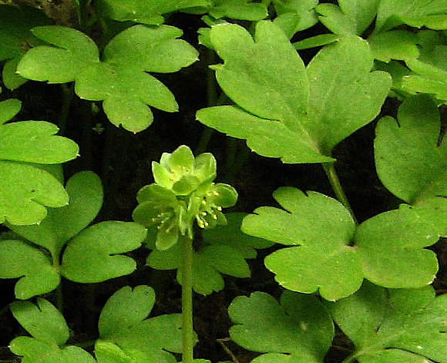
GO WILD! Plants to look for in April
A tiny pale green-flowered plant, Moschatel (Adoxa moscatellina) needs searching for very soon. Also known as Town Hall Clock or Five Bishops in a Pulpit, it has five faces on the flowerhead, one of them being on the top. It is often only 2 to 3 inches high so will soon be hidden by the taller vegetation. It grows on woodland edges and in gaps in old species-rich hedgerows. Try the top of Chapel Lane in the hedge opposite the big five bar gate near the green triangle, also on hedge banks where Penylan Lane joins CoedyGo or by Trefonen Hall ford.

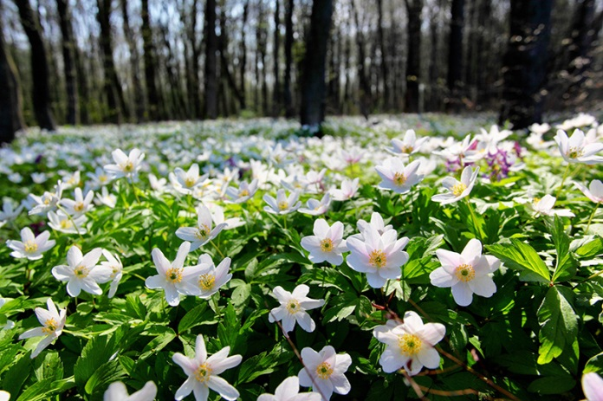
There are some super patches of Wood Anemone (Anemone nemorosa) around on verges, hedge banks and woodland edges. Usually white-flowered, but sometimes tinged pink or purple; this one is always a delight so see.
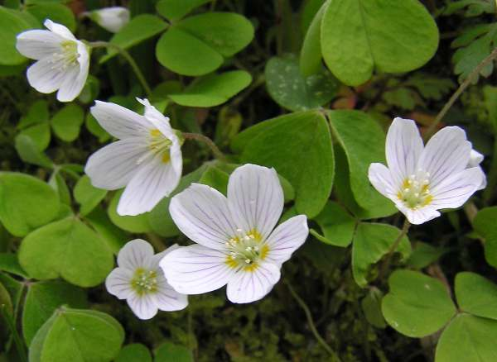

Wood Sorrel (Oxalis acetosella) is not quite so common around Trefonen, but can be found by the sharp eyed. There is a small patch of it in the hedge by the stile beyond the Fairy Bridge. Look for small white drooping flowers with exquisite lilac veins and bright green trefoil leaves.

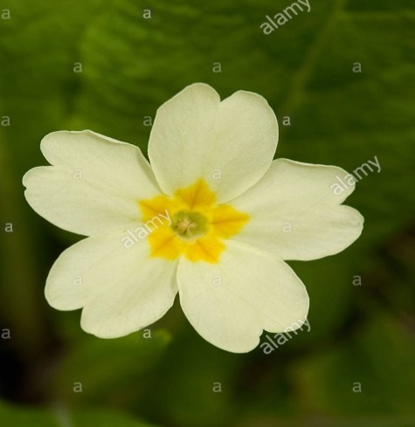
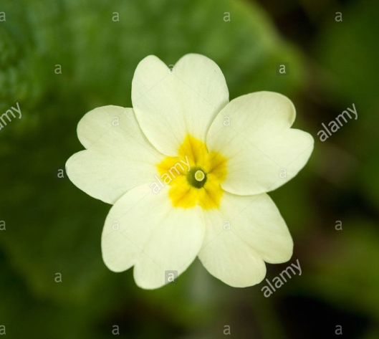
I am sure that everyone recognises Primrose (Primula vulgaris), but have a look and see if you can find both pin eye and thrum eye forms and look up why this is beneficial to pollination. It is lovely to see the show of primroses in Trenant cemetery, on the corner of Chapel Lane, this spring. Can you add a photo of any of these to the Village Facebook page?

Pin-eye . Thrum-eye

