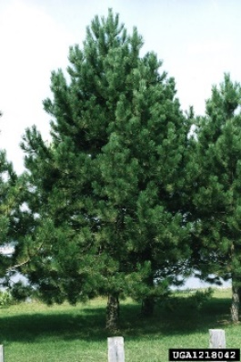
A Christmas tree and a celebration of the Coronation

Mel Oakley has been exploring the possibility of siting a Christmas tree on Chapel Green, linking this to planting a tree to celebrate the Coronation. A permanent tree would mean no problems each year sourcing a tree and then disposing of it. She approached the Parish Council for advice, and they asked Chris Woods, a councillor, to meet with her on Chapel Green. Trees for Trefonen have been allocated specific spaces on the Green by Shropshire Council, owners of the land. The Trees for Trefonen Co-ordinator showed them the position of an as yet unused space which they thought ideal for their purposes.

The sourcing of the tree has been worked out and Mel is now seeking to raise the money to fund its purchase and planting. She will be organising tree buddies to look after the tree and keep it weed free. If you would like to donate towards this, there is a box in the Village Shop or you can drop your contribution off to Mel at 58, School Lane, on the corner just opposite the War Memorial Green.

Thank you in advance for your support.

K Kimber (T for T) 01691 679646 bobnkkimber@btinternet.com

